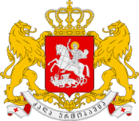
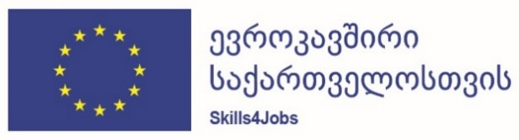

Assistance to Skills Development for Matching Labour Market Needs
ტექნიკური მხარდაჭერა შრომის ბაზრის საჭიროებებსა და დასაქმებაზე
მორგებული უნარების განვითარებისთვის

Meeting of the Project Steering Committee
To be held online (login details to be confirmed by separate email)
Thursday 4th February 2021, 16.00 to 17.30
Draft Agenda

1. | Welcoming remarks  EU Delegation, Project beneficiaries | 16.00 – 16.10
2. | Overview of project implementation progress since the Second SC meeting in May 2020, including Covid-19 response  (June to August 2020: covered in Progress Report No. 2 (previously circulated); September 2020 to February 2021 will be covered in Progress Report no. 3 (being prepared)  PowerPoint by the Team Leader (10 minutes)  Questions and answers, discussion (10 minutes) | 16.10 – 16.30
3. | Project implementation and planning by Component  - Component 1: Policy  - Component 2: Skills Development  - Component 3: Youth  - Component 4: Employment Services  - Component 5: Data systems and analysis  - Component 6: Grant Scheme  PowerPoint by the Team Leader and Project Team (Total - 25 minutes)  Questions and answers, discussion (25 minutes)  (PowerPoint to be circulated by separate email) | 16.30 – 17.10
4. | Changes in Government structure  Discussion on possible implications of the separation of Ministry of Education and Science and Ministry of Culture, Sports and Youth | 17.10 – 17.20
5. | Any other business | 17.20 – 17.25
6. | Closing remarks  EU Delegation, Project beneficiaries | 17.25 – 17.30

